GIT Branching

Objective: Commit HTML, CSS & JavaScript assignments into GIT.

SECTION-3 (javaScript assignments) - Steps to follow:

1. Create a new branch 'js-assignments'.

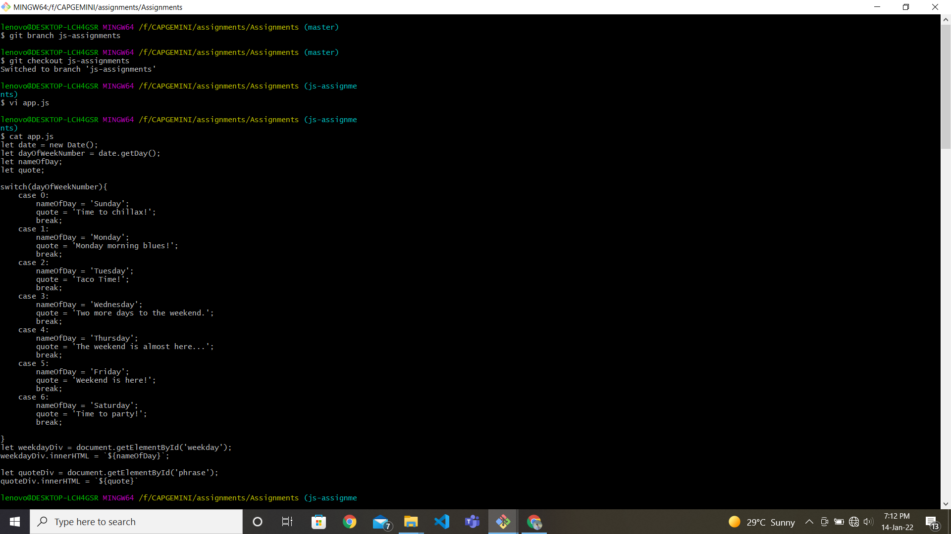

2. Switch to js-assignments' branch.



3. Copy all JavaScript assignments inside 'Assignments' folder,





4. Commit JavaScript assignments into 'js-assignments' branch.

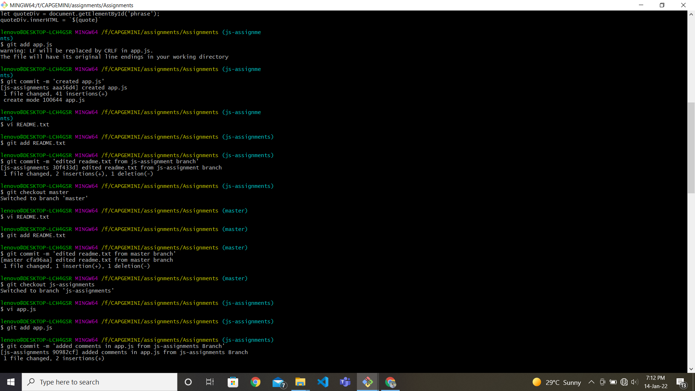

5. Make minor changes into README.txt file on line belonging to js-assignments" branch.

6. Commit those changed files.



7. Switch to master branch



8. Make minor changes into README.txt file on line 1 & commit those changes into master.



9. Again switch to js-assignments' branch.



10. Make minor changes into few files belonging to js-assignments' branch.



11. Commit those changes.



12. Switch to master.

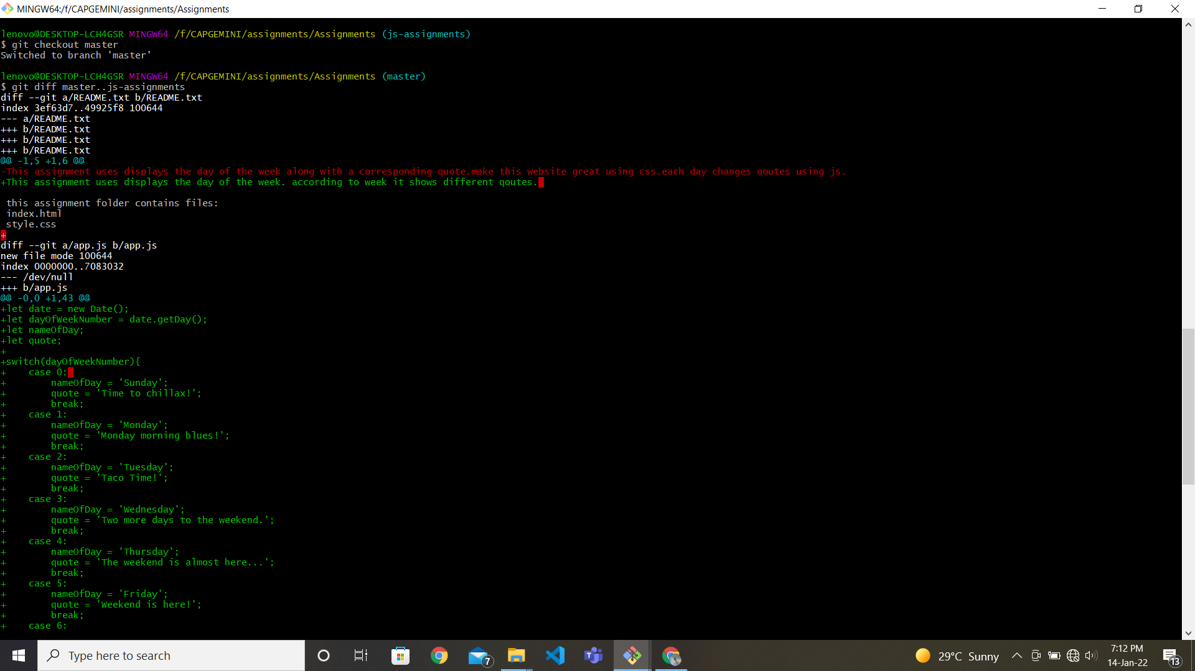

13. Merge 'js-assignments' branch into master. Confirm all JavaScript assignments are shown in master..

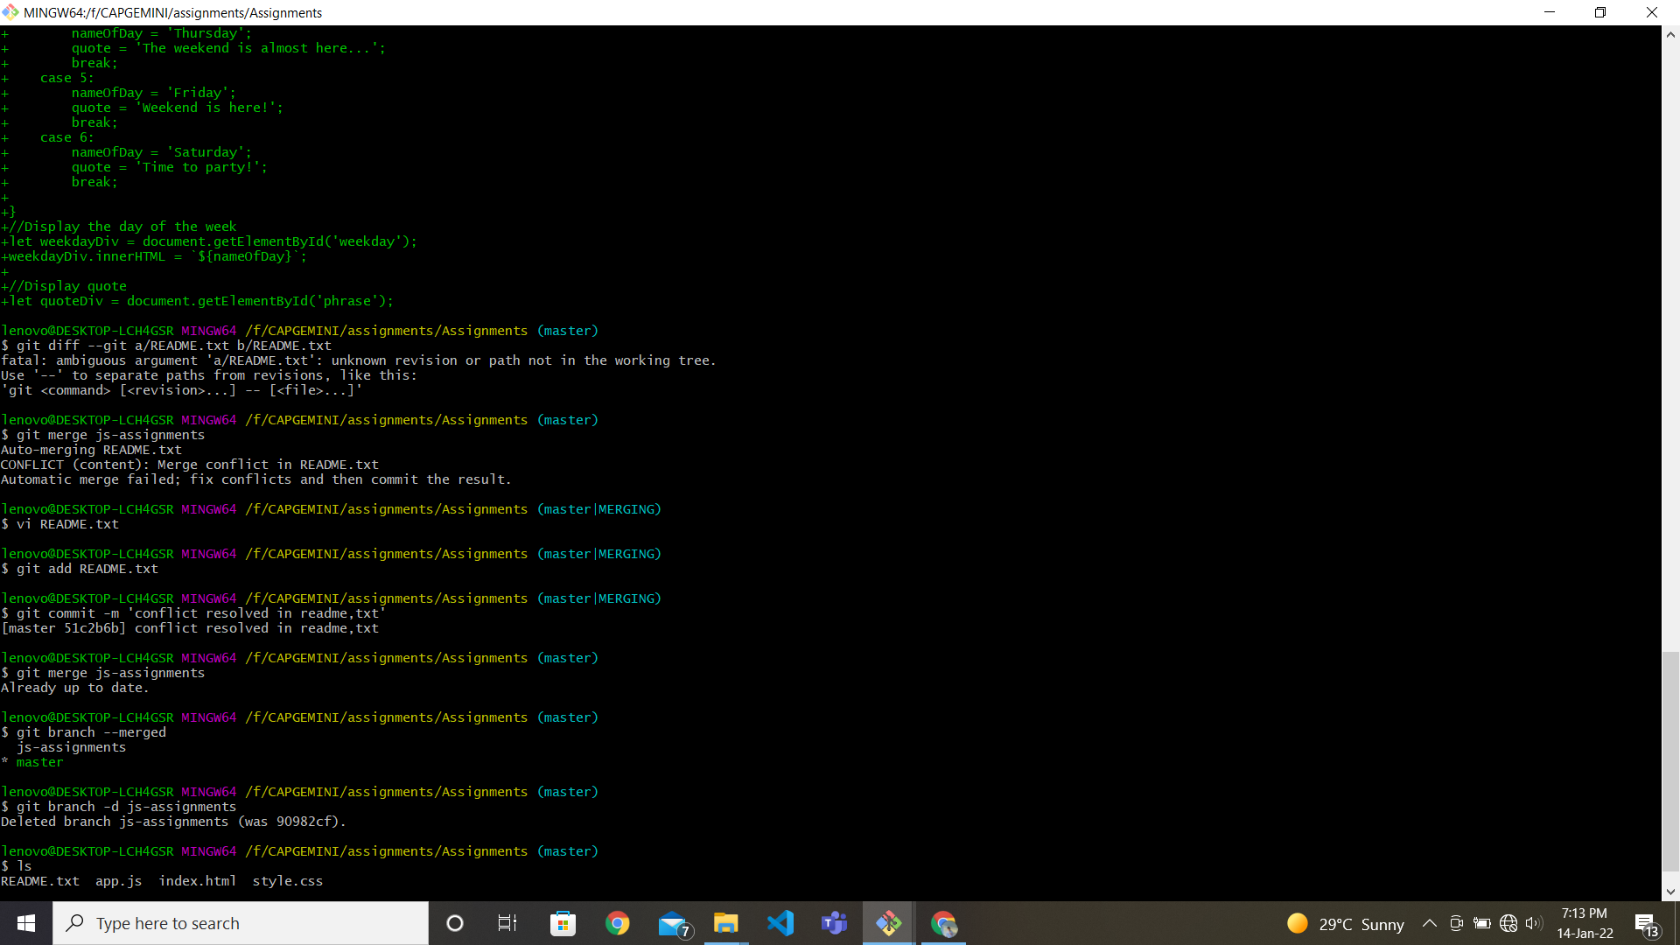

14. Finally delete the js-assignments' branch.

